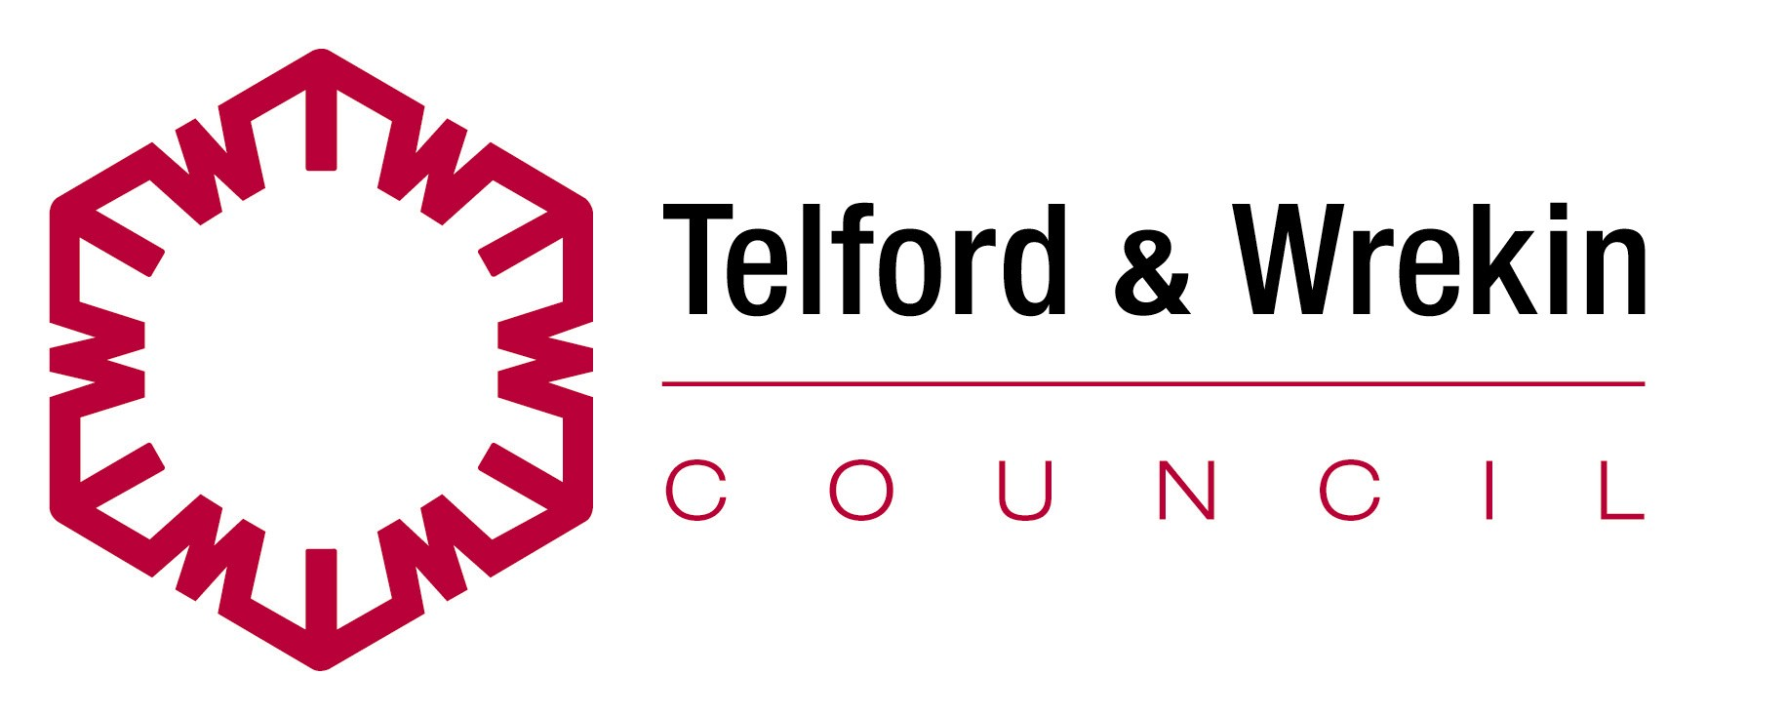 |  | 

e-billing– Access your invoice quickly and securely anytime from anywhere from your email

Agresso Customer ID

Please enter email address

Email  Address  (invoices will be sent to this address) | ______________________________________________

Please confirm email address

Email  Address  (invoices will be sent to this address) | ______________________________________________

Signed by applicant |  | Date

